

WEB SCRIPTING

CSE – 220 QUARTER V



September 24, 2020

M.Sathishkumar

E0119052

**Challenge 1:**

Add elements in array with index and find their length

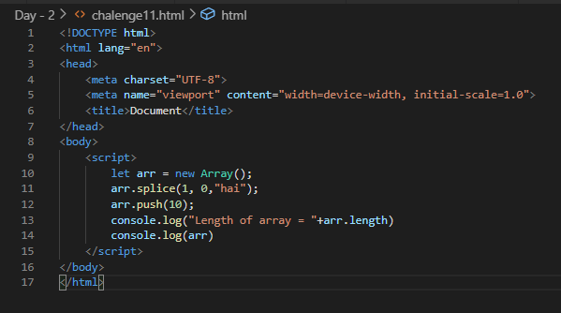

Output:

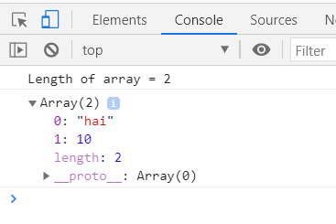

**Challenge 2:**

Assigning value to a specific index irrespective of already present values

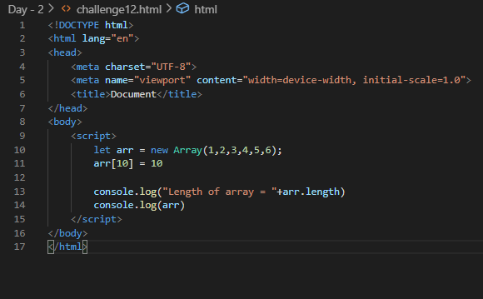

Output:

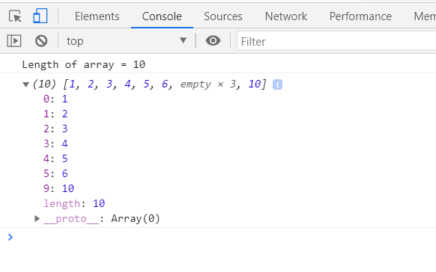

**Challenge 3:**

Check whether a number is prime or not

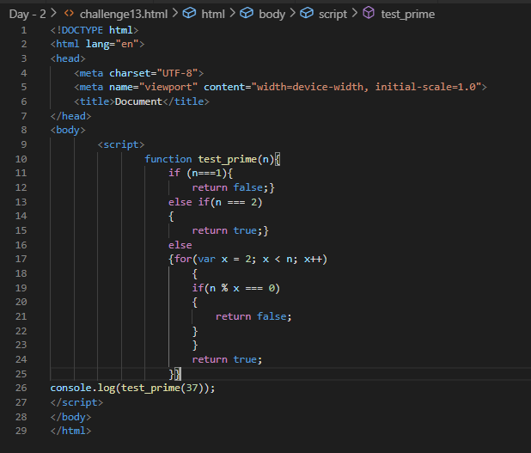

Output:



**Challenge 4:**

Write a function to display the properties of a function

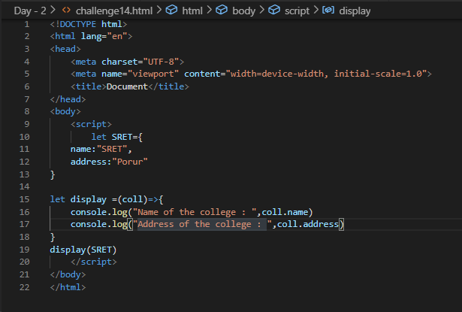

Output:

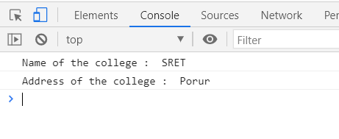

**Challenge 5:**

Using for/of and for/in to print elements

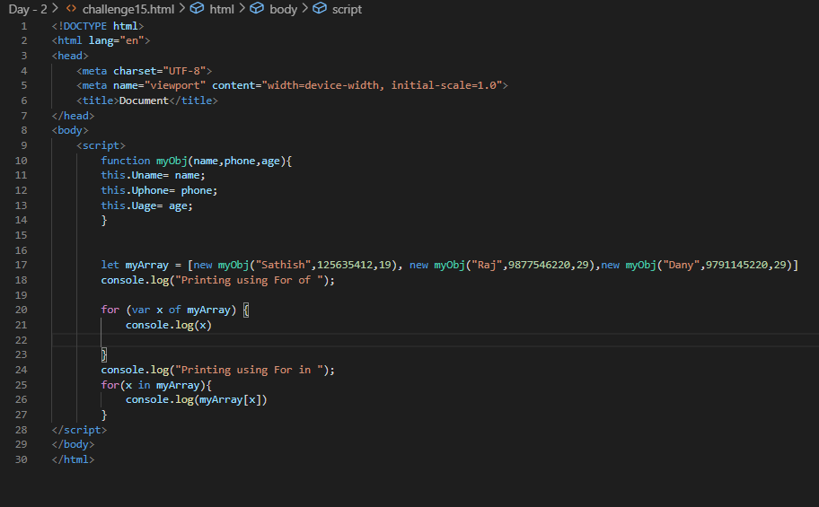

Output:

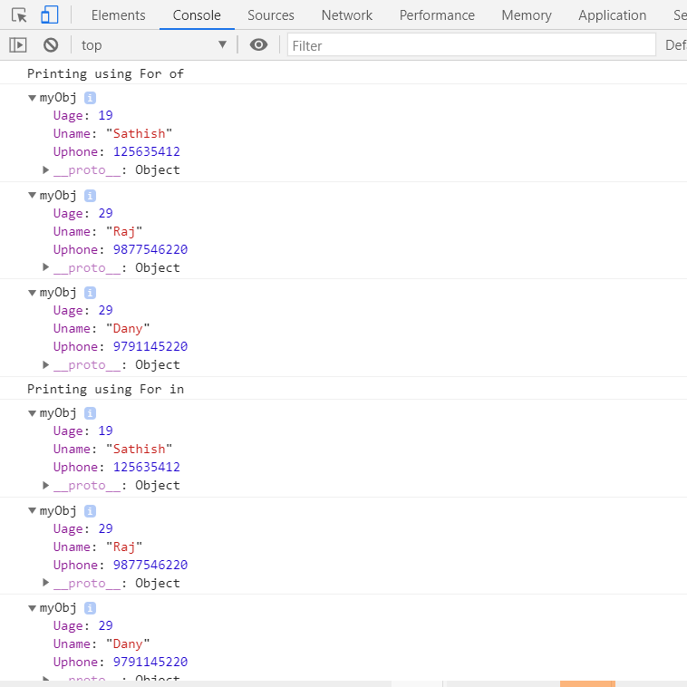

**Challenge 6:**

Code snippet to display different fruits and flowers

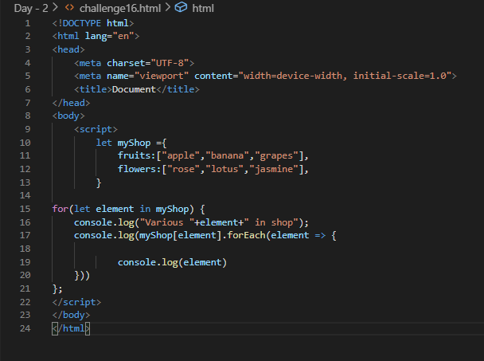

Output:

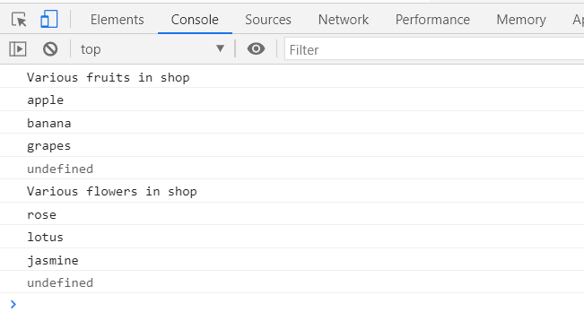

**Challenge 7:**

John and Mike both play basketball in different teams. In the latest 3 games, John's team scored 89, 120 and 103 points, while Mike's team scored 116, 94 and 123 points.

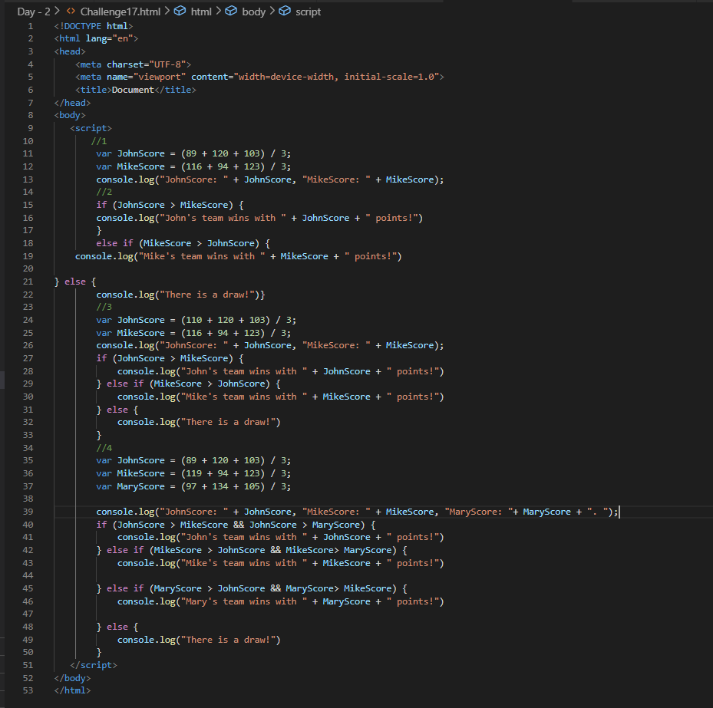

Output:

